OPERATING & SAFETY MANUAL
TILTING MACHINE
Clutch Plate Positioning & Tilting Station
Manufactured by:
Karthick Engineering & Maintenance Consultants (KEMC)
No 22/50, Manickavasagam Street, Kumaran Nagar, Padi, Chennai – 600050
End User: Valeo India Pvt. Ltd.
Machine Safety Assessment: Independent Safety Consultant
Document Version: 1.0 | Date: February 2026
Safety Evaluation Date: 16 February 2026

READ THIS MANUAL BEFORE OPERATING THIS MACHINE
Failure to follow safety instructions may result in serious injury or death.

Document Control
Document Title | Operating & Safety Manual – Tilting Machine
Document Number | KEMC-TM-OSM-001
Version | 1.0
Date of Issue | February 2026
Prepared by | KEMC Technical Documentation Team
Reviewed by | KEMC Engineering
Approved by | KEMC Management / Valeo Safety Officer
Safety Assessment Reference | Third-Party Machine Safety Evaluation – 16/02/2026
Next Review Date | February 2027 (or after any machine modification)

Version History
Version | Date | Author | Changes
1.0 | February 2026 | KEMC Documentation | Initial release

ℹ NOTE: This document is to be kept readily available at the machine workstation at all times. Copies must be provided to all personnel operating, maintaining, or supervising this machine.

Section 1: Machine Identification
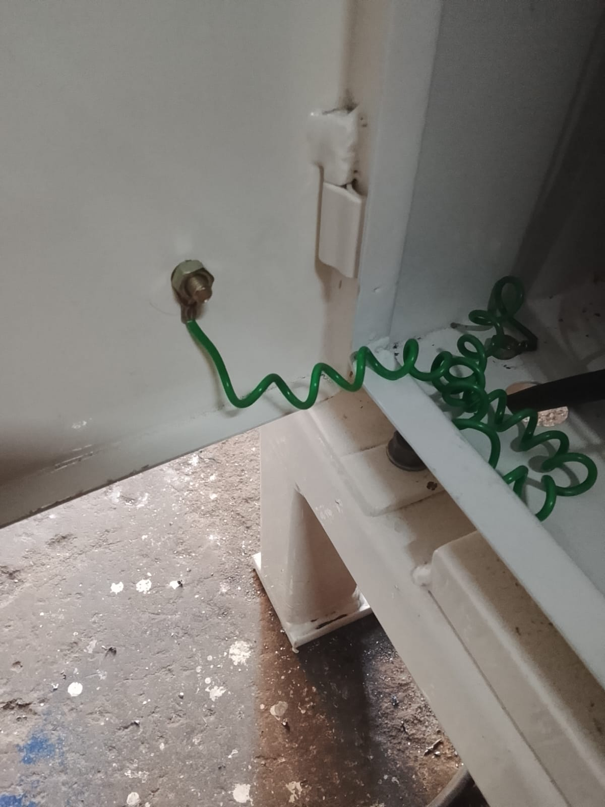
Figure 1.1: Tilting Machine – Front View

1.1 Machine Identification
Machine Name | Tilting Machine
Manufacturer | Karthick Engineering & Maintenance Consultants (KEMC)
End User | Valeo India Pvt. Ltd.
Manufacturing Date | February 2026
Machine Type | Assembly Machine – Clutch Plate Tilting Station
Safety Assessment Date | 16 February 2026

Section 5: Safety Devices

5.1 Fixed Perimeter Guard
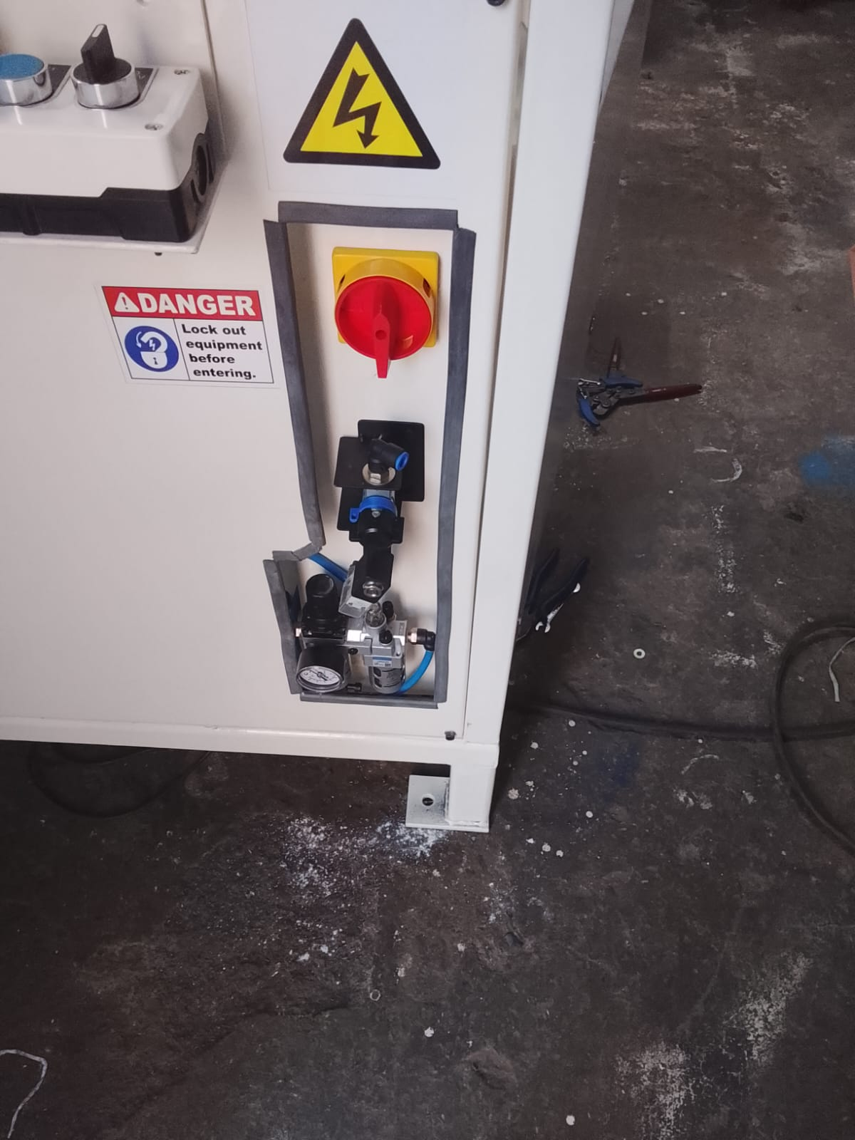
Figure 5.1: Fixed Mesh Perimeter Guard

Guard Type | Fixed Mesh Guard
Height | 700 mm
Mesh Gap | 20 mm
Status | Implemented

5.2 Light Curtain – Operator Access

Figure 5.2: Type 4 Safety Light Curtain

Device Type | Type 4 Safety Light Curtain
Top Beam Height | 1400 mm
Bottom Beam Height | 900 mm
Resolution | 14 mm

5.3 Control Panel & Cycle Start
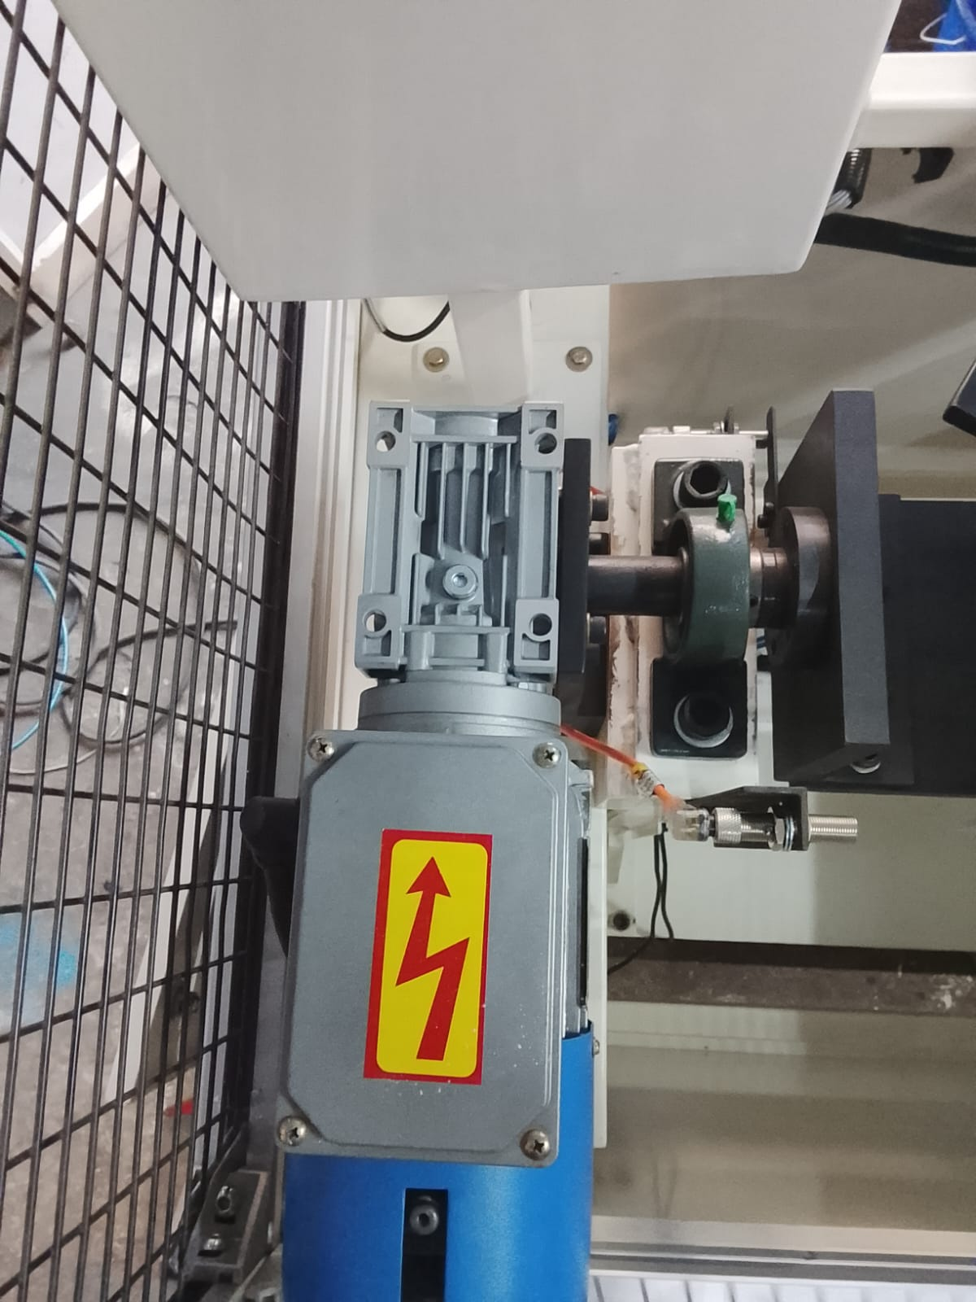
Figure 5.3: TEKNIC Control Panel with START Button

⚠ OPEN ACTION – Safety Enhancement Recommended
The safety assessment (dated 16/02/2026) recommends upgrading to a TWO-HAND CYCLE START CONTROL per ISO 13851. This would require simultaneous actuation of two separated buttons, ensuring both operator hands are clear before the cycle begins.
Current Status: Single START button. Two-hand control PENDING.
Until implemented, operator MUST ensure: (1) Both hands withdrawn. (2) Light curtain clear. (3) No personnel nearby. ONLY THEN press START.

5.4 Emergency Stop
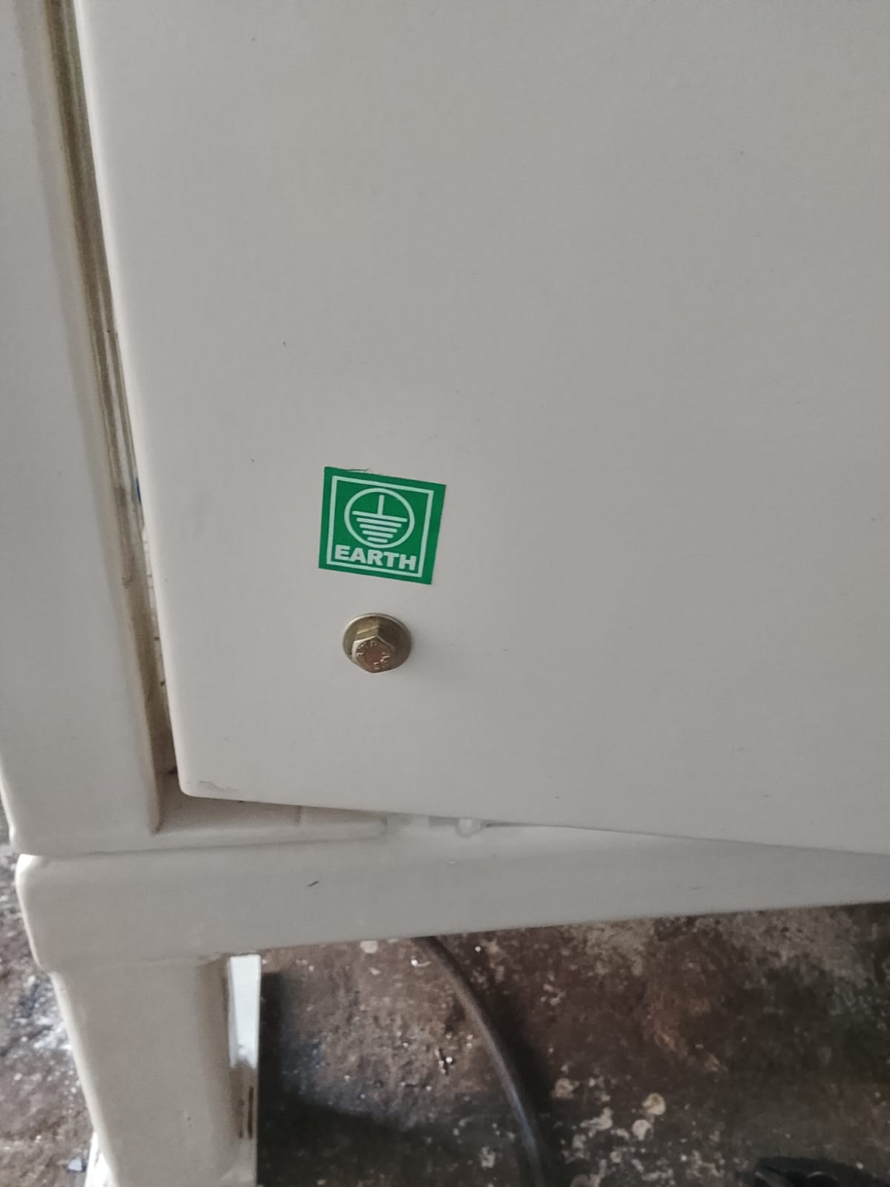
Figure 5.4: Red Mushroom-Head E-Stop Button

5.5 Pneumatic Isolation
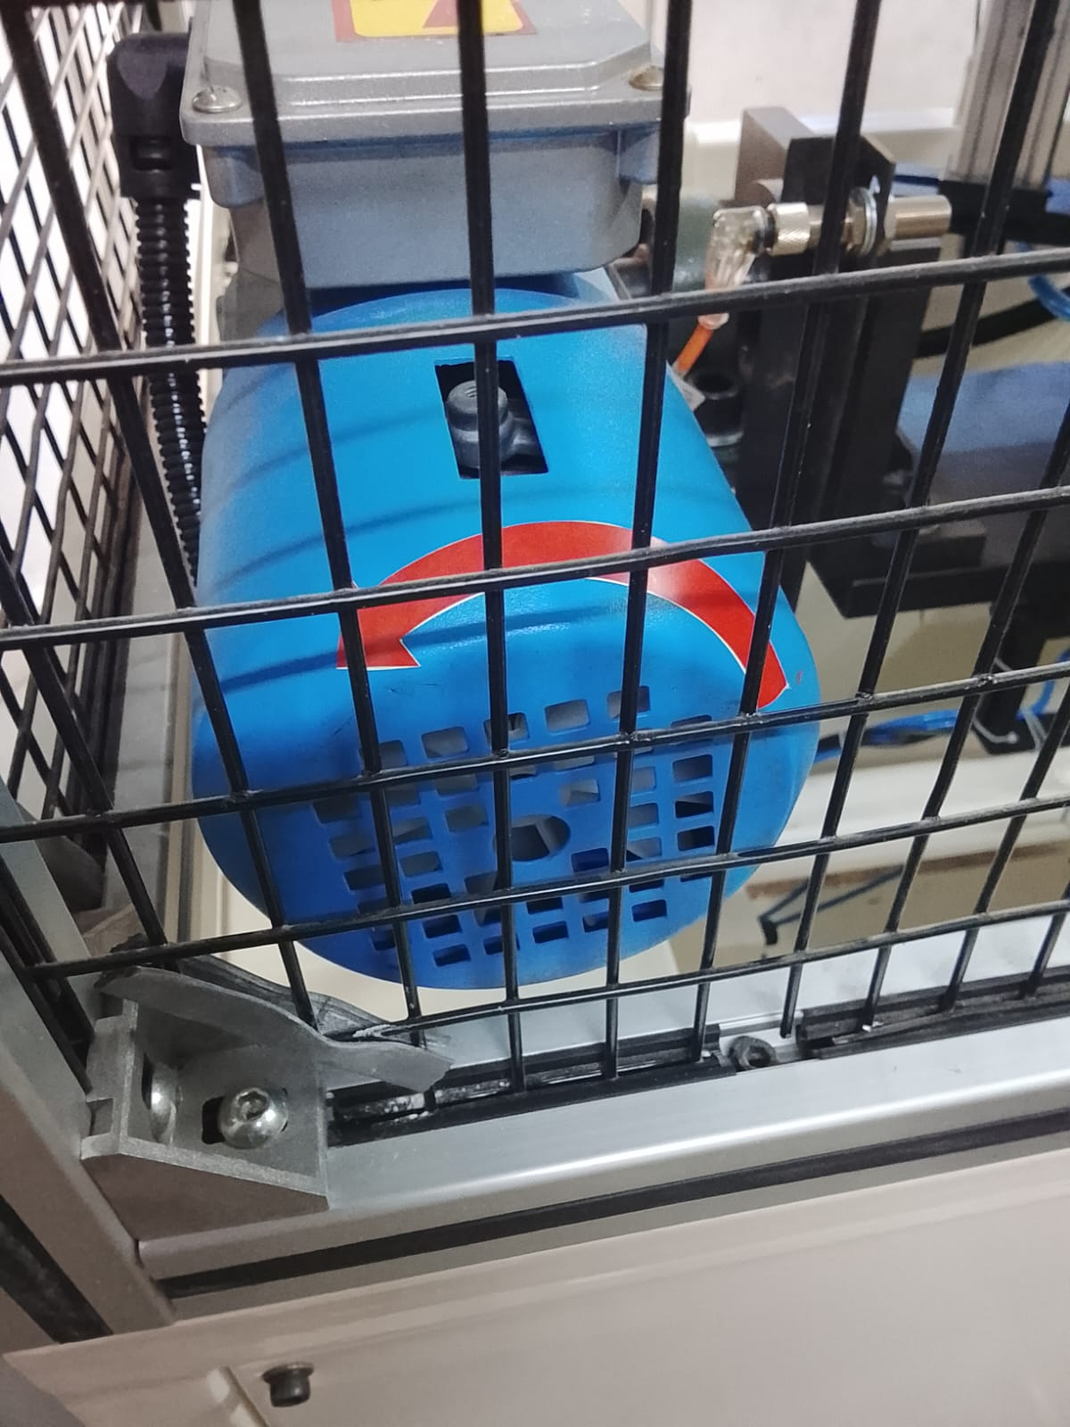
Figure 5.5: Blue Pneumatic Isolation Valve

5.6 Main Power Isolator
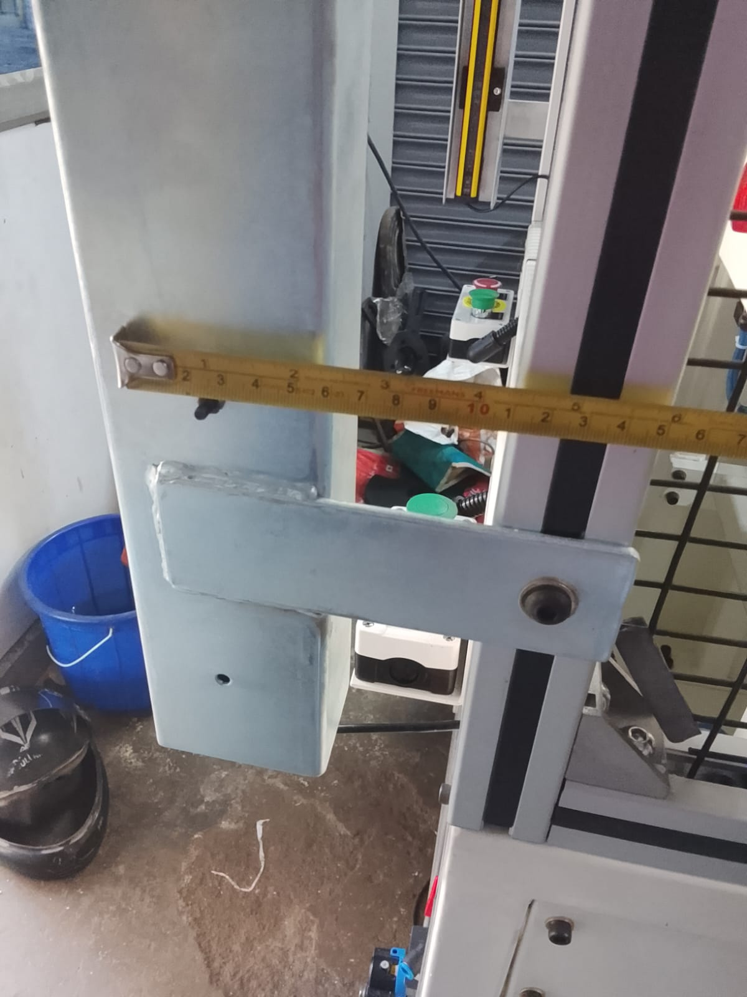
Figure 5.6: Main Power Isolator with LOTO Provision

Section 6: Machine Components

6.1 Tilting Mechanism
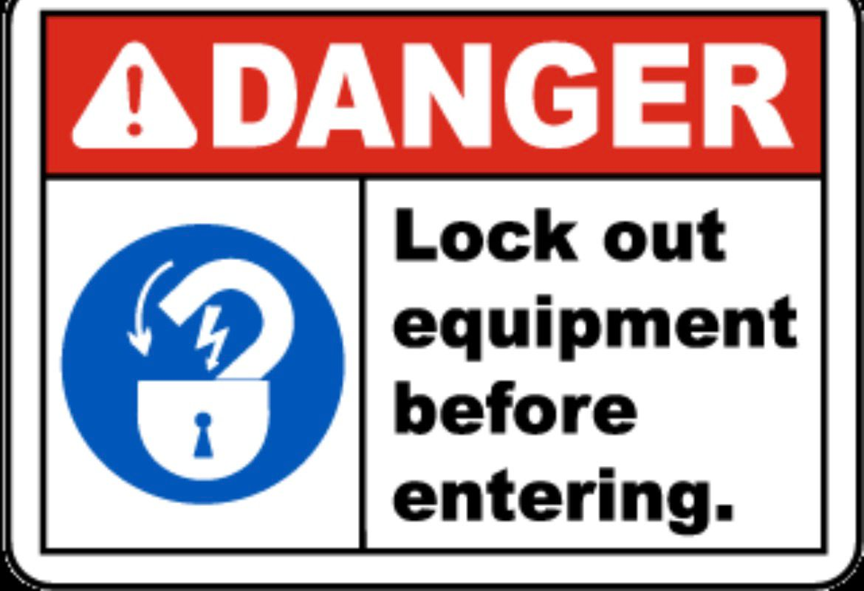
Figure 6.1: Electric Motor with Worm Gearbox (Tilting Drive)

6.2 Pneumatic System
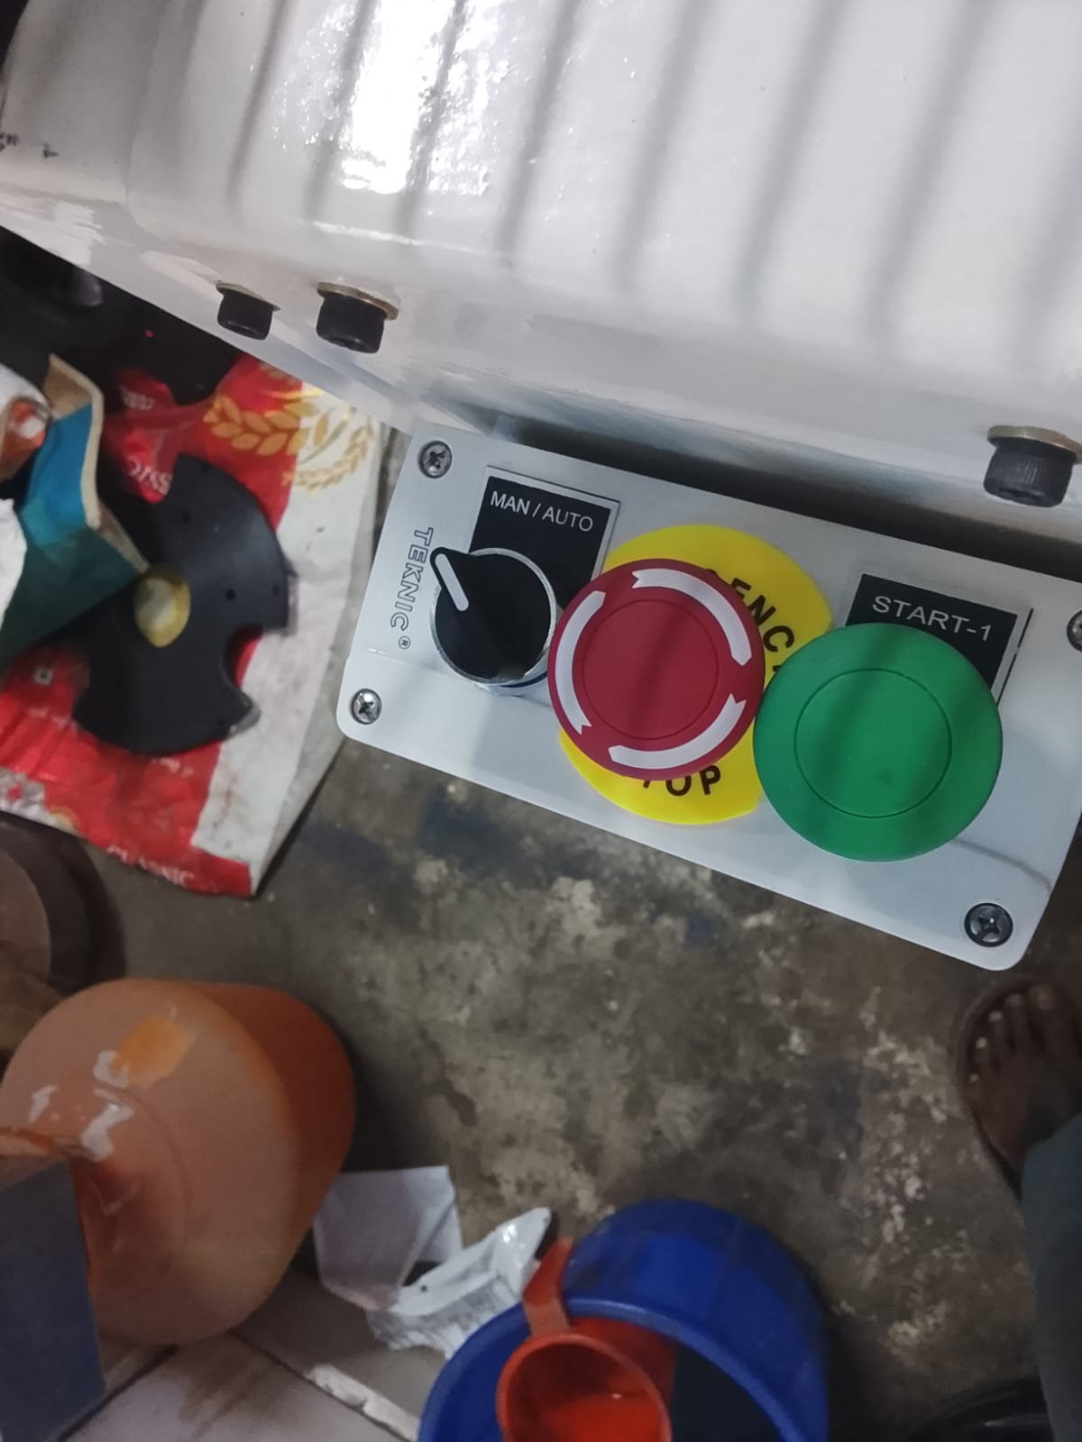
Figure 6.2: JANATICS FRL Unit with Pressure Gauge (5 bar)

6.3 Tilting Fixture
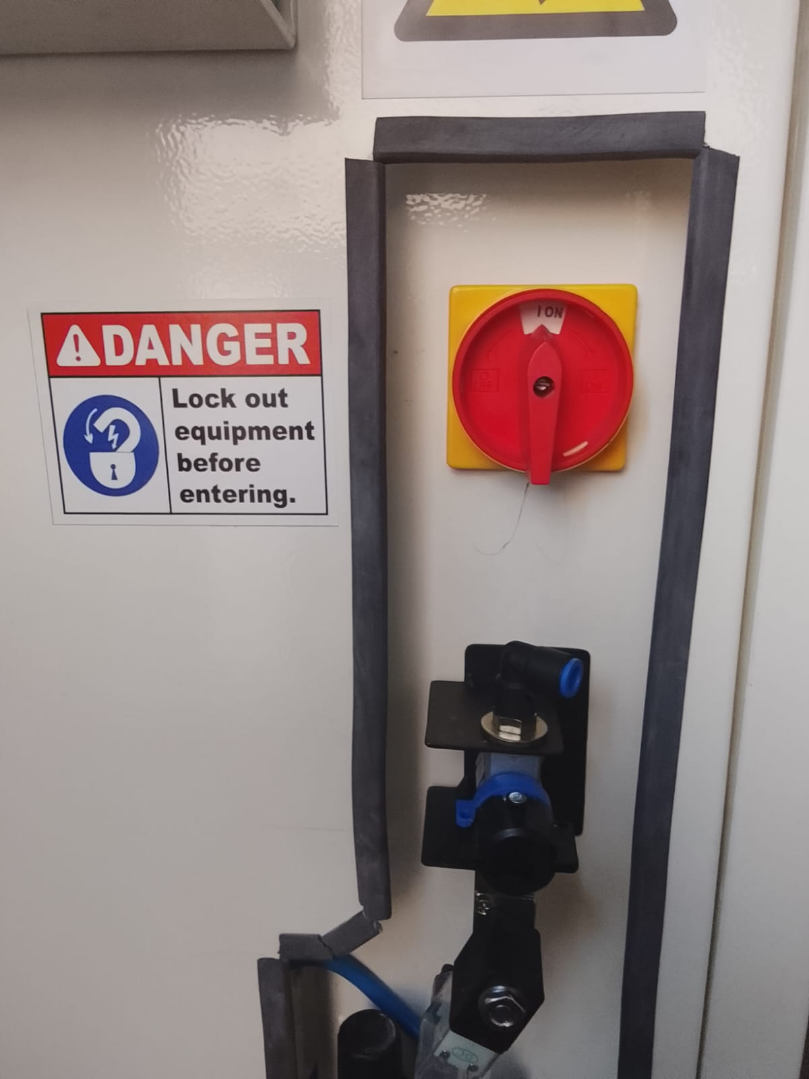
Figure 6.3: Tilting Fixture with Clamping Cylinders

6.4 HMI Display
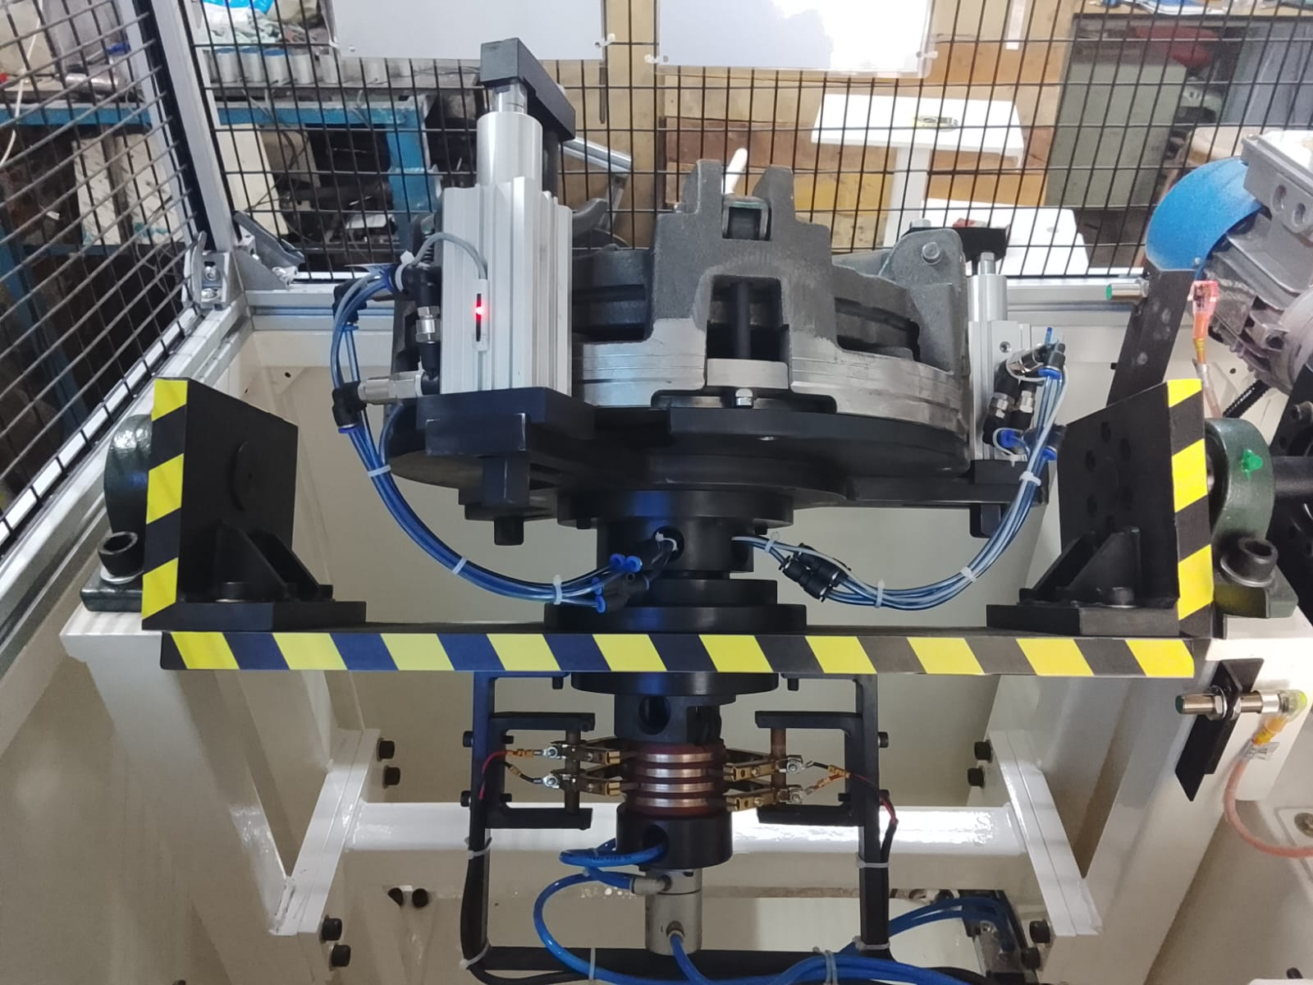
Figure 6.4: HMI Display Panel

6.5 Safety Signage

Figure 6.5: ISO 7010 Safety Warning Labels

